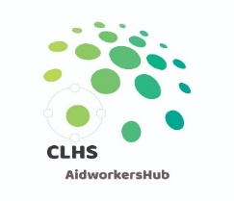

2-Day Sphere Training Program
DanChurchAid, Bulawayo
21-22 September 2021

Tobias Ndlovu, Global Humanitarian Advisor, DCA

Day 1: | Guiding Principles
Time | Session
8:00–8:30 | Arrival and Welcome (brief introductions, ground rules, overview, and objectives)
8:30–10:00 | STP 3: What is Sphere – Standards in Context
10:00–10:30 | Coffee break
10:30–12:00 | STP 4: The Humanitarian Charter
12:00–13:00 | Lunch
13:00–14:30 | STP 5: Protection Principles
14:30–15:00 | Coffee break
15:00–16:30 | STP 6: Core Humanitarian Standard

Day 2: | The Four Technical Chapters & Practical Application
Time | Session
8:30–10:00 | STP 7: WASH & STP 8: Food Security and Nutrition
10:00–10:30 | Coffee break
10:30–12:00 | STP 9: Shelter and Settlement & STP 10: Health
12:00–13:00 | Lunch
13:00–14:30 | STP 11: Using Sphere in Practice & STP 12: Sphere and the Programme Cycle
14:30–15:00 | Coffee break
15:00–16:30 | STP 16: Sphere and Coordination & STP 17: Sphere, Cash and Markets
16:30–17:15 | STP 20: Evaluation and Wrap-Up

