Humanitarian Response a quick Introduction overview:

HUMANitarian Response is to me foremost about YOU being HUMAN!

Here are is a collection useful humanitarian links which appear to be useful for me:
This list does not attempt to be complete or even up to date but you might find it useful for your human work.
Humanitarian Ethics:
“An appealing, thoughtful and compact introduction into humanitarian ethics by Hugo Slim based on a Master Class organized by KUNO, and the Netherlands Red Cross (The Hague, January 2019)”
https://www.kuno-platform.nl/learning/humanitarian-ethics/
The Humanitarian Charta:
Read the 5 pages of the Humanitarian Charta of the Sphere Handbook:
https://spherestandards.org/handbook-2018/
Assessment:
Short thought:
I want to stress that assessments are usually not inclusive. Assessment are often just focussing on needs and not on capacities. You can thrive to take more time to listen to people and their voices. Go a step further and create trust. If you are trusted by people and communities maybe you can give power away to those people and communities in order for them to take their own decisions on their own lives.
HUMANITARIAN NEEDS ASSESSMENT - THE GOOD ENOUGH GUIDE
(be always aware if you read the “needs” assessment and cannot find anything on capacities!)
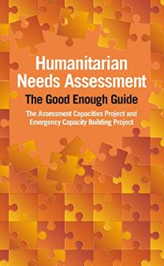
Download here and use this homepage for a good source of Humanitarian Assessment information: https://www.acaps.org/methodology/needs-assessments
Introductory Videos on Assessments: a) “What we need to know about disasters” - https://www.youtube.com/watch?v=yZuWuHgA2HA&t=74s ; b) “Three keys to humanitarian needs assessment” - https://www.youtube.com/watch?v=Sp8Gc2cvBhM&t=3s c) “analysis of information in humanitarian emergencies” - https://www.youtube.com/watch?v=7_-JNRXPtYU
Monitoring disasters:
www.gdacs.org – Register with Virtual OSOCC (THE coordination platform in case of a large scale and get sms/email updates
www.pdc.org – this homepage also provides an app
https://www.humanitarianresponse.info/

THE Humanitarian Minimum Standard:
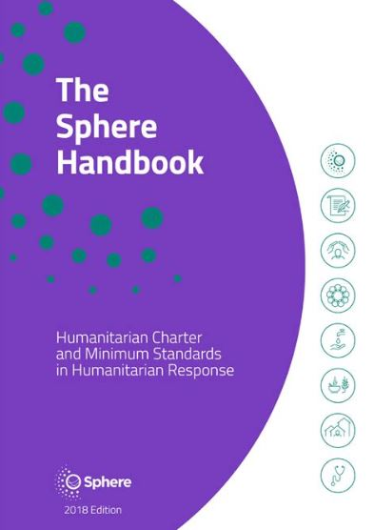
Sphere: https://spherestandards.org/ (free to download – free useful online handbook version)
Free online course on Sphere: https://spherestandards.org/online-courses/
Introductory Videos on Sphere (also on youtube):
https://spherestandards.org/resources/?category=video&lang=all&years=all&postTag=all&pages=1
Sphere Complimentary Standards:
Free App with all standards: https://spherestandards.org/humanitarian-standards/app/
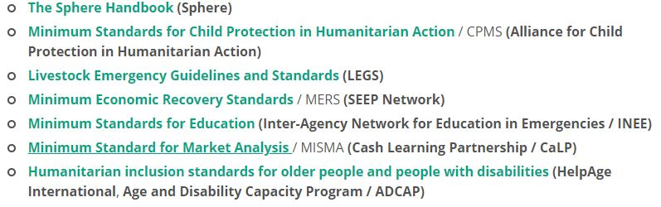
Introductory Video: https://spherestandards.org/humanitarian-standards/standards-partnership/
Age and Disability Inclusion in Humanitarian Response:
Washington Group Questions:
http://www.washingtongroup-disability.com/
Introductory Video: https://my.hidrive.com/lnk/h4AKHiXe
App by CBM for disability inclusion in the field: https://www.cbm.org/news/news/news-2017/cbm-launches-humanitarian-hands-on-tool-hhot/
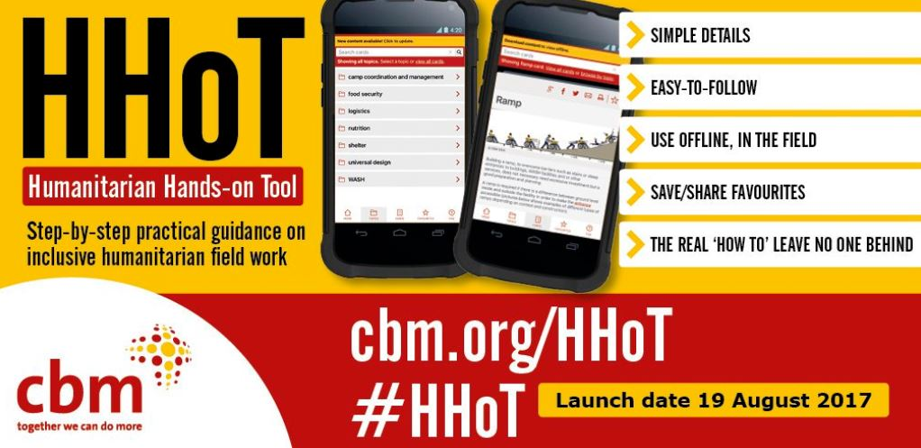
Humanitarian inclusion standards for older people and people with disabilities https://www.helpage.org/what-we-do/emergencies/adcap-age-and-disability-capacity-building-programme/
Inclusive Humanitarian Rapid Needs Assessment (example Rohingya Bangladesh): https://reliefweb.int/report/bangladesh/rohingya-refugee-crisis-bangladesh-age-and-disability-inclusion-rapid-assessment
Video by ASB Indonesia on Disability Inclusive Assessment: https://drive.google.com/file/d/1qvv7wFrdoUFveXn91wjkgdsBHsXr9NIe/view?usp=sharing
Webinar on the Use of the Washington Group Questions: https://www.youtube.com/watch?v=rGRSTgekv6U&t=600s (further toolkit on that wider topic: https://www.humanitarianleadershipacademy.org/launch-of-learning-toolkit-on-disability-data-collection/
The Humanitarian Cluster System:
https://www.humanitarianresponse.info/en/coordination/clusters
Free online training opportunities on many other aspects of humanitarian response:
https://kayaconnect.org/
https://www.disasterready.org/
Platform for lessons learned and other studies:
The sector's largest library of resources on humanitarian evaluation, learning and performance: https://www.alnap.org/

Further Links:
10 Things you need to know on Cash Transfer: https://www.youtube.com/watch?v=V08DZytvjXg
ODI – Time to Let go: https://www.youtube.com/watch?v=k-mpUi-1Nps&t=7s
TedTalk – Locally Led Humanitarian Response Peter Walker (Sphere Maverick): https://www.youtube.com/watch?v=vCGjRIVdOpc&t=6s
Sphere Mavericks – also with Peter Walker: https://www.youtube.com/watch?v=mQyBjG4VVec&t=1s
Lessons Learned Ebola on community engangement: https://www.devex.com/news/while-ebola-outbreak-ends-in-eastern-drc-who-says-no-room-for-complacency-97576
Meaningful Participation Methods & Concepts:
https://www.iaran.org/webinar/aid-reimagined
Aid Re-Imagined
https://www.iaran.org/webinar/aid-reimagined
https://medium.com/aidreimagined/do-no-harm-is-an-inadequate-moral-compass-heres-a-better-alternative-15799b24120f
Participatory Video
https://www.youtube.com/watch?v=wqI2_L4gVIg&t=81s
https://www.youtube.com/watch?v=7ig01x__otA&t=62s
PFIM People First Impact Method
http://p-fim.org/
"We cannot add value ... unless we know the existing value. We cannot know the existing value unless communities tell us. People will not tell us unless they trust us. They will not trust us unless we know how to listen and engage"
(P-FIM Case Study, 'Shifting the Power' August, 2017)

https://www.youtube.com/watch?v=TPU1HxqLmgM
https://www.youtube.com/watch?v=TTAmzNlL-d0
SCLR Survivor and Community Led Response
https://www.local2global.info/ look at the video
https://www.youtube.com/watch?v=hW96SIvVRuo
WHO on Lessons Learned Ebola – Community Engagement is key! https://www.devex.com/news/while-ebola-outbreak-ends-in-eastern-drc-who-says-no-room-for-complacency-97576

