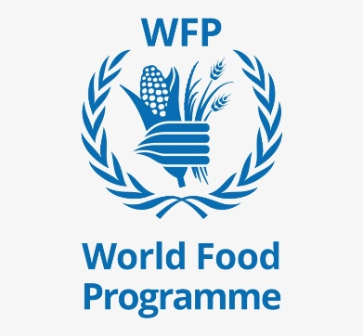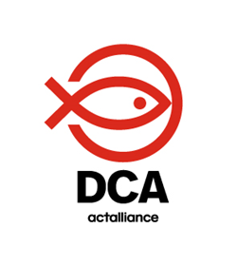

SPHERE TRAINING
BLUE HILLS CAMP, BULAWAYO, ZIMBABWE
21-22 September 2021

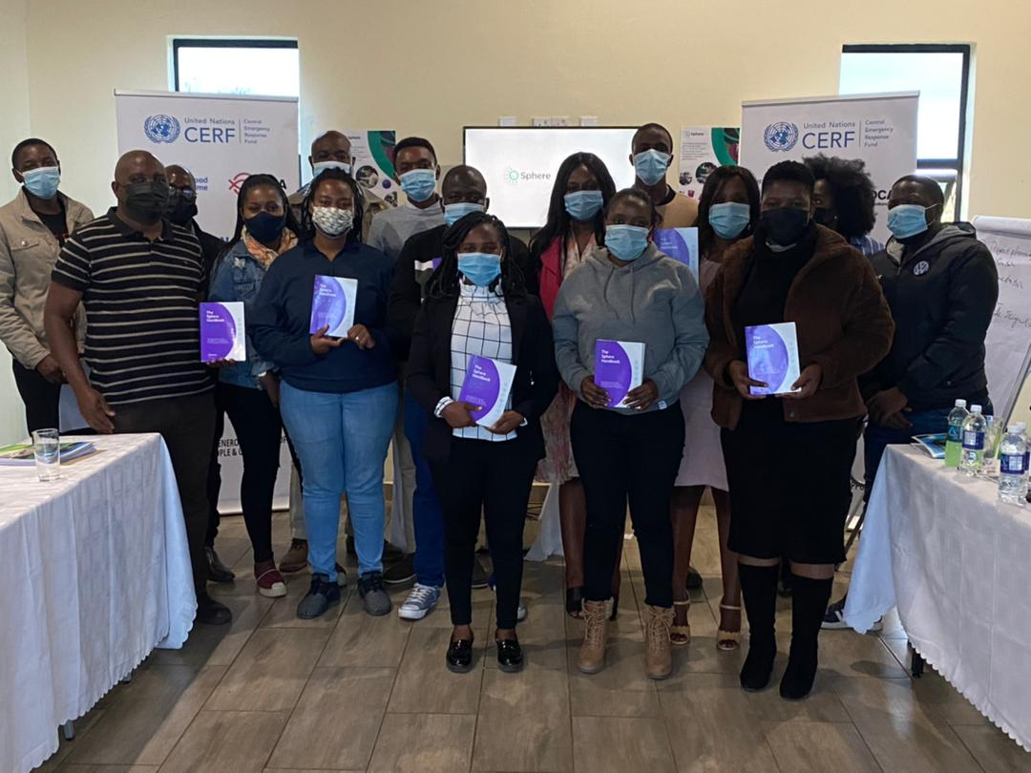

BACKGROUND
The training was scheduled and attended by DanChurchAid (DCA) staff members who are currently implementing the Urban Social Assistance Project in Bulawayo, Zimbabwe funded by World Food Program (WFP). The training also included staff members of DCA’s implementing partner- Organization of Rural Associations for Progress (ORAP). The training was initially intended to be a refresher training but after consultations with the staff from both DCA and ORAP, it was discovered that all the participants had not been trained before hence it became a complete training compressed in 2-days. To assess the current level of competency and opinions on different aspects of humanitarian work ahead of the training, the participants were requested to complete an individual check-up form which was shared with the facilitators after completion. The responses guided the facilitators to tailor the program focusing on the critical issues highlighted by the participants on the individual check-up form. The training was facilitated by the DCA Global Humanitarian Advisor and co-facilitated by the DCA Grants & Compliance Manager. The comprehensive objective of the training was to equip the Urban Social Assistance staff members with Sphere knowledge and most importantly on how to use to use the Sphere handbook linking it with daily humanitarian activities and focusing on the four foundation chapters and four technical chapters.
PARTICIPATION
The training was attended by a total of 14 participants, thus 8 Females and 6 Males. These are members of the team implementing the Urban Social Project in Bulawayo. The following is the breakdown of the nature of the participants and their current roles in the project implementation:
Name of Participant | Sex | Current Sphere Level | Role
Olwin. S Manyanye | Female | First time training | Project Co-ordinator
Zimazile Ncube | Female | First time training | Protection Officer
Nomuhle Mhlambeni | Female | First time training | Senior Field Officer
Charity Fengu | Female | First time training | Complaints Handling Officer
Cynthia Maphosa | Female | First time training | Cash & Markets Officer
Arnold Sitshoni | Male | First time training | M&E Officer
Gabriel Ncube | Male | First time training | M&E Assistant
Beauty Ncube | Female | First time training | Field Officer
Kamilo. S Tshuma | Male | First time training | Field Officer
Winston. S Ndebele | Male | First time training | Field Officer
Mbongeleni Ndlovu | Male | First time training | Field Officer
Colleta Ncube | Female | First time training | Field Officer
Bongiwe Nkomazana | Female | First time training | Field Officer
Victor Baka | Male | First time training | Field Officer

GOAL /LEARNING OBJECTIVES
The overall goal of the objective of the training was to educate the DCA and ORAP staff to acquire knowledge on the Sphere Minimum standards of operation and how to apply the minimum standards in their humanitarian response activities. The specific learning objectives focused on:
- The Sphere origins and what has changed currently using videos and group work.
- The application of the minimum standards in humanitarian response. This was achieved through knowledge assessment by quizzes and group work.
AGENDA
The training was compressed into 2-days and ensured that all the topics were covered within the stipulated timeframe. The first day focused on the following sessions- DAY ONE:
What is Sphere- Standards in Context
This session was attentive to the introduction of Sphere and its origins to the participants. Participants were also taught how to manoeuvre through the Sphere handbook and to take note of the Sphere Core beliefs, which indicate that people affected by disaster or conflict have the right to life with dignity and therefore the right to assistance, meaning that all possible steps must be taken to alleviate suffering. A video detailing the origins of the Sphere minimum standards was played and this assisted participants to get a clear understanding of the reason why the Spere standards were created.
The Humanitarian Charter
Participants were allowed to first give their understanding of the word ‘charter’. The facilitator built on the responses given to commence the presentation that began by informing participants that the Humanitarian Charter provides the ethical and legal backdrop to the Protection Principles, the Core Humanitarian Standards and the Minimum Standards in the handbook. Participants went through a handwritten quiz after the presentation to measure the level of understanding of the session. The outcome of the quiz showed that 99% of the participants understood the session.
Protection Principles
The Protection Principles of enhancing the safety, dignity and rights of people, and avoid exposing them to harm, ensuring people’s access to assistance according to need and without discrimination, assisting people to recover from physical and psychological effects of threatened or actual violence, coercion or deliberate deprivation and helping people claim their rights. The objective of this session focused mainly on how the participants apply these protection principles to their day-to-day humanitarian work activities. The facilitator placed the participants in groups and shared scenarios with them and participants had to match each scenario with the correct protection principle. The outcome of the group work expressed that 97% of the participants understood the application of the protection principles when conducting their humanitarian work.

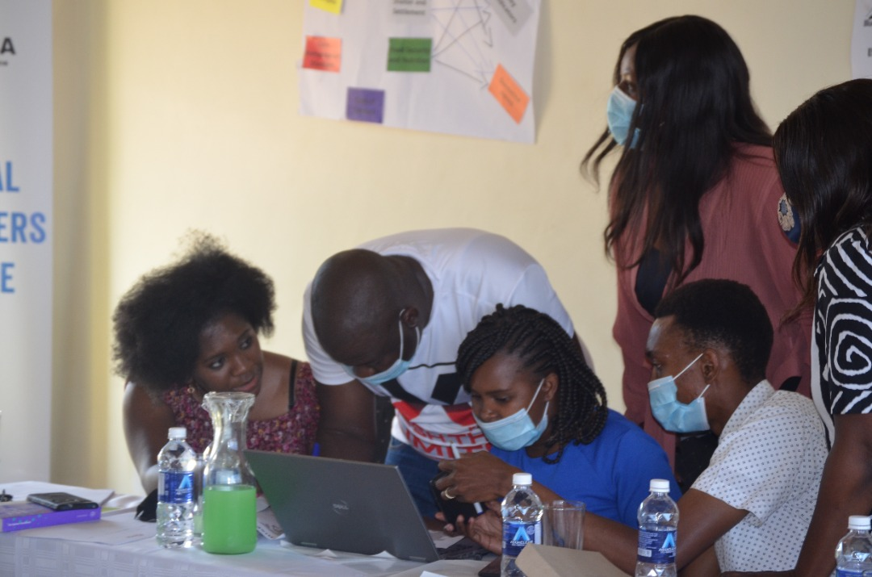
Figure 1 Participants during a group discussion
Core Humanitarian Standards
This session was structured in a manner that allowed the participants to engage fully in the discussion through engaging them on their understanding of the core humanitarian standards. The facilitator focused on allowing the participants to discuss how they apply the 9 commitments to the daily humanitarian work. The objective of this training was for the participants to get an understanding of how to properly apply the 9 commitments in their work. In groups, there was a discussion on how these can be applied in daily activities. The main take-away for the participants was to understand that the standards apply both at the response and programme level and in all phases of a response. The groupwork revealed that 80% of the participants were able to link each committed to their daily duties in humanitarian work.
DAY 2-The second day of the training shifted to the technical chapters and practical application. The sessions were separated in the following manner:
WASH & STP: Food Security and Nutrition
The second day of the training aimed at educating and engaging the participants to fully demonstrate the best ways of applying the foundation chapters and the technical chapters. The successful implementation of the technical chapters is intertwined with the foundation chapters. The facilitator played a video and participants were requested to note emerging issues relating to WASH for discussion. The critical outcome of the discussion was to display the interconnectedness that exists between WASH, Food Security and Nutrition, Shelter and Health. This linkage needs to be considered during project implementation and not let one suffer to achieve a holistic approach.
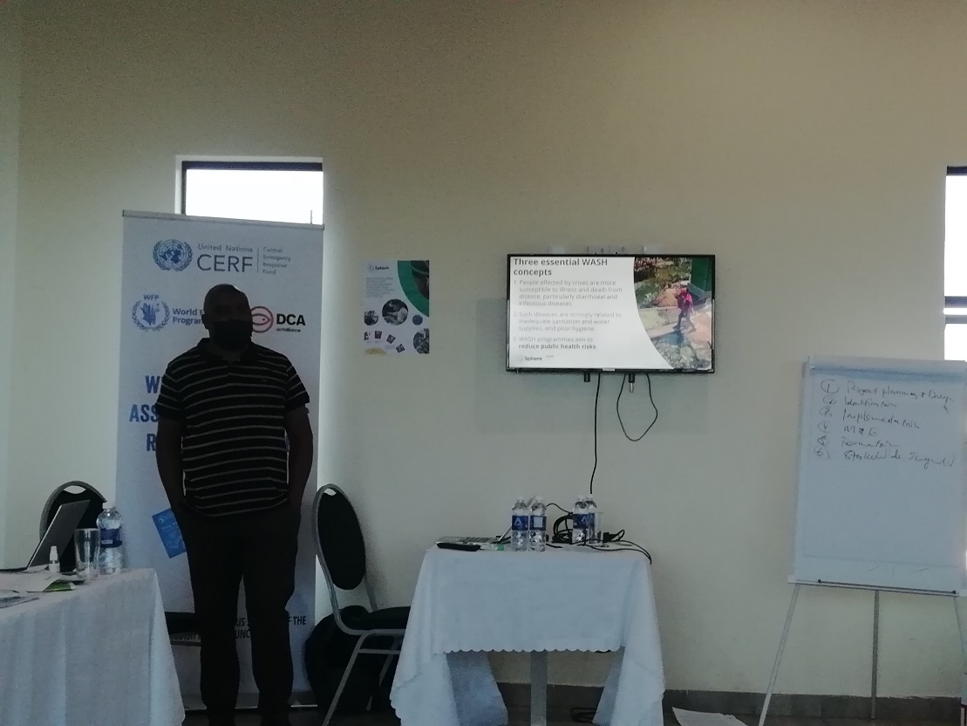
Figure 2 The facilitator giving a presentation on WASH
Shelter and Settlement & STP Health
The objective of this session was to once again engage the participants to understand how they can utilise the handbook in coming up with Shelter and Health programming. The focus was on the indicators to work with and the key action points to adopt. Participants took time to watch a video and discussed in groups the key observations from the video.

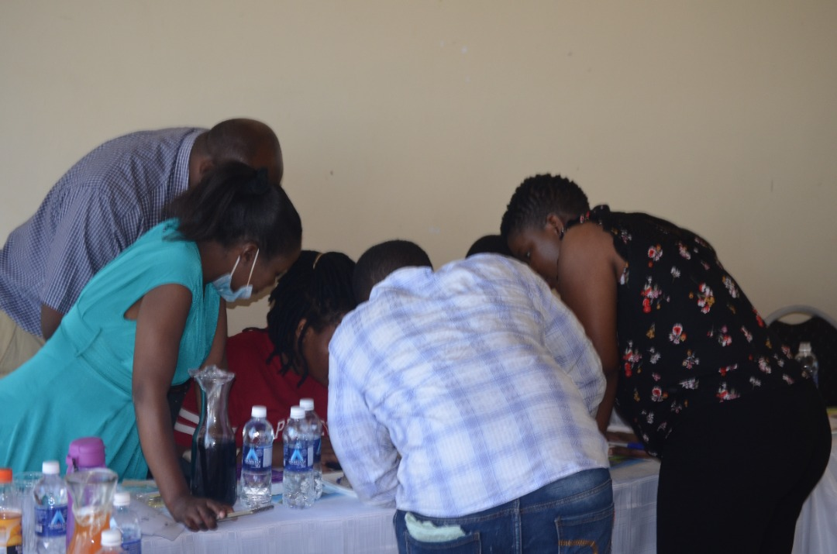
Figure 3 Participants during a group discussion on the issues noted on the video
Sphere and Coordination: Sphere, Cash and Markets
DCA and ORAP are implementing the Urban Social Assistance Project which has a Cash and Markets pillar. It was prudent that the training demonstrated the connection between Sphere and Cash and Markets. The facilitator gave participants cash and markets scenarios in which they had to link with the key actions highlighted in the handbook. The outcome of the exercise indicated that 100% of the participants understood the link between Sphere and Cash and Markets programming. Participants took part in a Sphere and Coordination i. The main objective of the quiz was to assess the participants full understanding of the coordination of all the foundation and technical chapters.
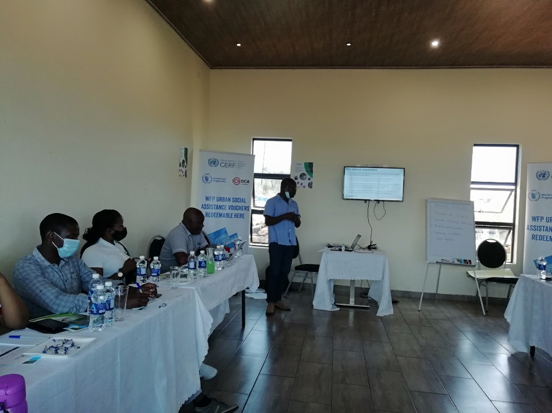
Figure 4 The facilitator leading a discussion on Cash and Markets
Using Sphere in Practice: Sphere and the Programme Cycle
The objective of this training was to enlighten the participants on the best ways of using the Sphere in the programme cycle. The focus for the participants was to discuss which parts of Sphere are most useful in difficult situations. A video was played, and participants had to identify Sphere guidance and advice they would use during a difficult situation. The outcome of the discussion revealed that all the participants (100%) were able to identify the parts of Sphere they would utilise in a difficult situation.
SUMMARISED PARTICIPANT SURVEY RESULTS

The 2-day training ended on a high note with participants glad to have taken part in such an enlightening and fruitful training. Below are the quotes obtained from the workshop evaluation form. The quotes are anonymous:
‘The training is very useful and could be done yearly for all staff. The facilitation was good and allowed for participation
‘The training was enlightening and capacitating, I now understand issues on the interconnectedness of different technical sectors, and this would be of help in my work as an M&E person’
‘Training was productive and informative as it addressed my work-related issues’
The training was attended by 14 participants. The overall workshop evaluation form revealed the following outcomes, as indicated in the bar graphs below, which shows that out of the 14 participants all of them revealed that the training was relevant to their job and 98% agreed that the subject matter was adequately covered. The bar graphs measure the responses of the participants as highlighted on the evaluation form. The bar graphs also stipulate the responses given by the participants by numbers:

CONCLUSIONS
The event was compressed into 2-days and all sessions were covered within the timeframe. Despite that it was a success, it is crucial that more days are put in the planning for the training to assist sessions to be covered holistically. As a way forward, the organizers will work on ensuring that a refresher training is planned, and adequate time is given for the training. The participants were urged to download the handbook online while the organizers are working on ensuring that all participants get a hard copy of the handbook. Most importantly, participants will from the event be guided by the minimum standards in their daily operations and constant communication amongst the organizers and participants will be created and maintained.

