Sphere Session for SIMEX. May 2022

Outline programme

Learning outcomes

By the end of the session, participants will be able to:

- Explain Sphere’s philosophy
- Navigate the Sphere Handbook
- Give examples of a principled humanitarian response
- Differentiate between Standards and Indicators
- Say why analysis of context is vital
- Give examples of actions that support the nine CHS commitments

Time | Description | Slides
0900  10’ | Welcome participants and introduce self. Ask: How is it [SIMEX] going?  Ask: Who knows about Sphere? On a scale of 1 – 10, where are you? Put hand up if you are leaning towards 1… or towards 10.  Assuming most are somewhere in the middle, ask: So what do you know? And what do you want to know?  Give an brief overview of the session.
0910  15’ | Say: Let me take you back to 1994.  Give a few examples of things that happened in 1994 (e.g. Clinton and Yeltsin and dismantling of nuclear arsenal in Ukraine, LA earthquake, etc) before mentioning Rwanda genocide.  Discuss Rwanda genocide and birth of Sphere project.  Discuss Quality and Accountability and brainstorm what these words mean. Discuss Rights and Rights Based Approach, and Humanitarian Principles (ref Legal Framework but not in detail). | 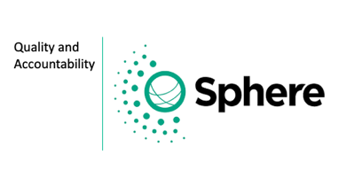
0945  15’ | Show video: ‘Humanitarian Standards Partnership (HSP) Introductory Video’ (3’11”)  Ask participants to download handbook. Give them a few minutes to do this and explore, in pairs, the content. Invite observations on how the handbook is structured.  Split group into teams of 6 people.  Then start quiz, asking series of questions to relate to different chapters, sections, etc. (Questions highlight how Sphere Handbook is structured – eg principles first, context, guidance, actions, standards v indicators, etc)  Elaborate on answers and take questions from group as you go.  Finish with ‘What is the Standard for water access and quantity? Highlight the difference between the Standard and the Indicator. | 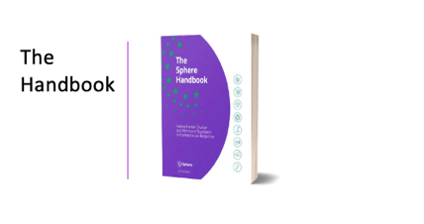  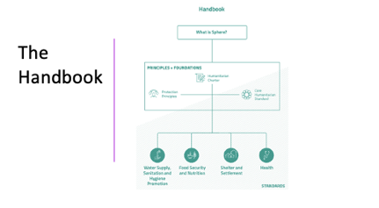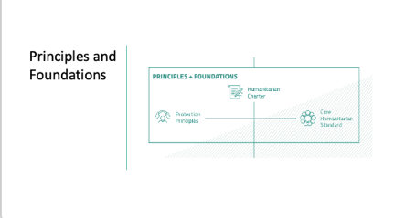  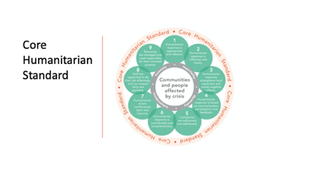
1000  45’ | Divide into three groups and assign each group to table where three activities are set up. Explain that they will have 15 mins at each activity before moving to the next.  Visit each group to check progress and answer questions. Signal when it is time to move to the next activity.  Activities:  - Take one card each. Take turns to say what concrete actions you would take to meet the Commitment on your card. Have someone check The Handbook for actions.  - Take one card each. For each picture, discuss whether the standard is being met. What you might to achieve the standard?  - Take one card each. Pick a standard from your card and say what actions you might take to achieve that standard. Keep the four Protection Principles in mind. Have someone check The Handbook for actions. | Activities:  1. CHS Commitments  2. Standards vs Targets  3. Principles to Action  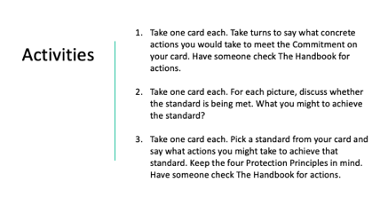
1045  15’ | Debrief each activity and highlight key learning points from each, i.e.  - The CHS is a voluntary set of commitments, achievable actions and policies, processes and systems guiding a principled, accountable and high quality humanitarian response. The 9 commitments are not merely aspirational statements. Words must be backed up with actions.  - Pursuing targets rather than standards is to assume that everyone is born with equal needs, rather than equal rights. Always consider the context – including people’s needs, capacities and vulnerabilities – and involve crisis affected people at every stage in the response.  - Key actions in the Handbook are suggestions and may not be applicable in all context. Actions must be consistent with the Protection Principles.  Show video: ‘What is new in the Sphere Handbook 2018?’ by way of summary.  Invite questions and wrap up session.

Stephen Blakemore
May 2022

