Sphere Training

Addis Ababa (Concern Worldwide Country Office, Addis Ababa, Ethiopia)
Dates: From July 1-3, 2024
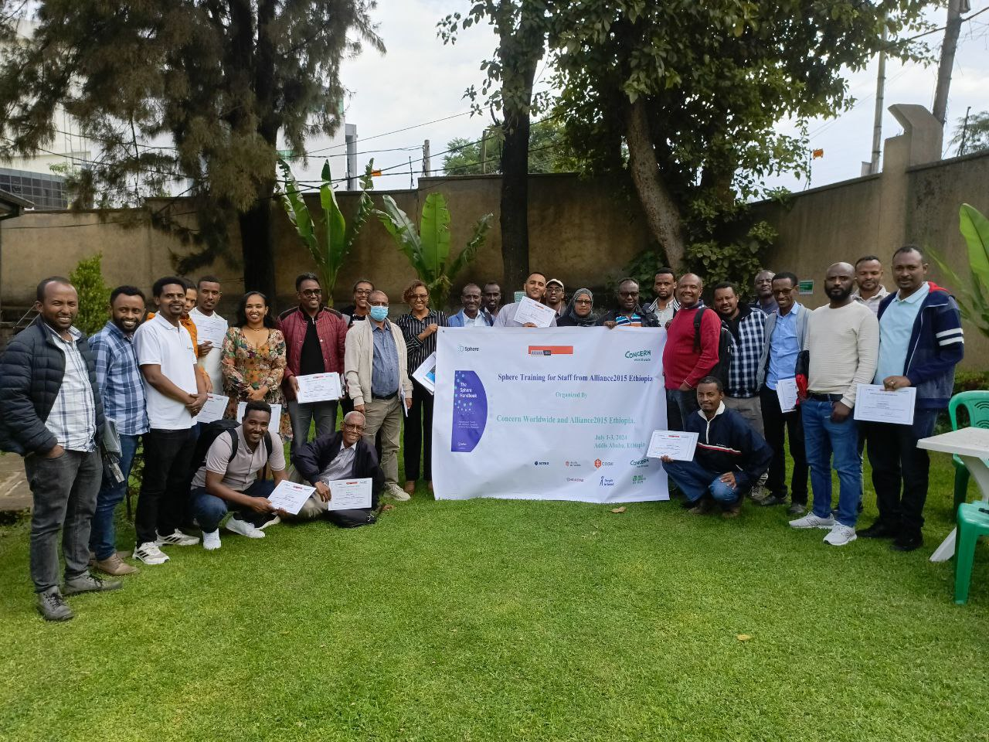
Group photo of participants (Credit to Kalkidan Jabir, Senior Communication & Advocacy Officer, Concern Worldwide)

Introduction
Efficient and effective humanitarian responses to people affected by crises or conflicts contingent upon high-quality services and accountability of actions. Humanitarian organizations play a critical role in the prompt provision of life-saving services for people affected by crises. The provision of quality services to uphold human rights and dignity primarily to save lives and relive suffering and assist to rebuild lives by humanitarian agencies contingent upon their technical capacity, expertise, and familiarity with the local context. The humanitarian sector has come to realize that developing capacities and institutional knowledge is key to being an accountable organization.
The training was conducted in person for three consecutive days from July 1-3, 2024. The organizers of the training are Concern Worldwide and Alliance2015 Ethiopia with the overall objective of helping the participants to better understand and apply sphere standards in their respective roles and workplaces. The event that led to organize it is the Sphere ToT Training conducted in Ethiopia in last December 2023 that was jointly organized by the Dutch Relief Alliance Project and the Inter-Agency Accountability Working Group in Ethiopia (IAAWG-E). All four of the training facilitators (Betsegaw Botamo, Ayenew Bekele, Elshaday Surafel and Hana Moges) are participants and graduates of the Sphere ToT training conducted in Ethiopia that is mentioned above.
Participation: Number and nature of participants
The total number of participants were 24 (4F). They were nominated from six Allinace2015 member organizations such as ACTED, Ayuda en Accion, Concern Worldwide, Helvetas, People in Need and Welt Hunger Hilfe (WHH). The participants were sent from Addis Ababa, Afar, Borena, Wolaita, Arsi, Mekelle, Hawassa and Somali work places. That means Addis Ababa and six other regional states were represented. An online pre- training launching workshop launching meeting organized prior to the workshop.
Goals/learning objectives
The main objective of the training was to help the participants better understand the sphere handbook and apply their works. The specific objectives include:
- To help participants understand the foundation, structures and content of the sphere handbook
- To increase the knowledge and understanding of participants on minimum sphere standards in WASH, Food Security and Nutrition, Shelter and settlements and Health sectors
- To help participants to easily navigate through the sphere handbook
- To create understanding to the participants how CHS and sphere and interlinked
- To increase the knowledge and skills of the participants on CHS and sphere so as they will better apply the standards in proposal writing, reporting, and networking, among others.
- To equip the participants with the sphere and CHS standards so that they will contribute more to quality and accountable humanitarian responses.
Methodology
A wide variety of methodologies were employed to attain the objectives of the workshop. Plenary discussions, quizzes, case studies, matching exercises, videos, games, small group exercise, pair work/ buzz, personal reflection, sharing experience sessions, and whole group discussions were implemented. The four-day workshop sessions began with a recap and reflection/setting participants' backgrounds in line with the daily session, proceeded with clarifications of expectations and activities, then content presentation in plenary discussion/video watching, small and large group participatory discussions, organizational experiences, and reflections, and end up with key messages summary and wrap-up. In between sessions, energizer activities, key messages and takeaways, and tea break hot discussions were applied. Moreover, practical experience-sharing opportunities are created to deepen understanding and relate the workshop with practice.
Workshop Evaluation
SUMMARIZED PARTICIPANTS SURVEY RESULTS
Overall, the participants’ responses indicated that the Sphere training sessions were well-received. The majority of the participants rated the events as "Very Good" or "Good” and expressed high likelihood to recommend future events by the same organizers.
The survey was analyzed on the following topics areas
- Training Content and Delivery
  - Most respondents were Very Satisfied or Satisfied with the training content, facilitation, and overall organization.
  - Participants appreciated the interactive and participatory nature of the training.
  - A few suggestions were made to extend the training duration and consider different venues outside the office setting.
- Knowledge Increase
  - Respondents reported significant to great increases in their knowledge across the key Sphere topics covered, including Humanitarian Charter, Protection Principles, WASH, Food Security, Shelter, and Health Action.
  - Some additional topics like MEAL, PSHEA, and coordination/partnership were also highlighted as areas of increased knowledge.
- Instructors Feedback
  - The instructors (Ayenew Bekele, Betsegaw Botamo, Elshaday Surafel, and Hanna Moges) were highly rated, with most respondents agreeing or strongly agreeing that the instructors met the stated objectives, communicated clearly, and were engaging.

- Overall Satisfaction and Impact
  - The majority of respondents strongly agreed that the training content and objectives were met, and that they feel more confident and better prepared to apply the Sphere standards in their work.
  - Several participants expressed plans to cascade the training to their organizations and use the knowledge gained to improve quality and accountability in humanitarian responses.
SAMPLE QUOTES FROM PARTICIPANTS
- "The training contents are clear and to the point."
- "I am enthusiastically waiting to be part of this training and Highly Motivated."
- "The instructors treated students with respect and could answer questions well."
- "As a result of attending this event I am more confident and better prepared to meet the relevant challenges in my professional life."
SUGGESTION FROM PARTICIPANTS
- Consider extending the training duration to allow for more in-depth coverage and practical application discussions.
- Explore alternative training venues that are outside the regular office setting to create a more conducive learning environment.
- Continue to leverage the expertise of the highly rated practitioners and instructors for future Sphere training events.
- Encourage attendees to share learnings and best practices within their organizations to amplify the impact of the training.
In general, the survey results demonstrate the value and effectiveness of the Sphere training sessions in enhancing the participants' knowledge and preparedness to apply humanitarian standards in their work.
Other reflections made by the participants:
- The participants appreciated this applying the entire sphere handbook (foundational chapters and technical chapters).
- In WASH programmes, in particular, and in all humanitarian responses, in general, community engagement requires innovative approaches for lasting impacts
- The need to further contextualize the malnutrition indicators and standards to local and national contexts rather than directly using the WHO standards (which may be far from the local contexts in some cases)
- In Ethiopia the shelter and settlement partners use the same prototype of materials in all regions regardless of the differences in needs and preferences across sub-national areas
- The Sphere handbook is a key tool for humanitarian advocacy works.
Lessons learned and recommendations
- Participants underscored the valuable contribution of sharing experiences and learning from others in such workshops as revealed in small group exercises, experience sharing and group mix
- Participant convinced that the existing gaps in provision of quality humanitarian response at grass root level and the complexity of global crisis and response over time and space justify the essence and continuity of the workshop
- Participants reflected on the importance and use of all parts of the sphere in their practice They emphasized the relevance of integrating CHS commitments in different cycles of the programme
- The workshop allowed us to clarify the misconception and distinguish between sphere minimum standards and indicators—standards differ from indicator
- The workshop helped us realizing the potential of meeting the sphere minimum standards under specific response context and measure process through multiple indicators
- They reflected the improvement in their capacity to use the sphere Handbook and familiarized with the updated standards and technical areas
- The HSPApp needs to be updated to match recent android version
- It would have been good if one day was added to this workshop event.
Conclusion
Overall, the Sphere training organized by Concern Worldwide and Alliance2015 Ethiopia aiming to enhance participants' understanding and application of Sphere standards in their respective roles and workplaces went very successful. The training was a result of the Sphere ToT Training conducted in Ethiopia, jointly organized by the Dutch Relief Alliance Project and the Inter Agency Accountability Working Group in Ethiopia. The participants on the training, who were nominated from six Alliance2015 member organizations, expressed high satisfaction with the training content, delivery, and overall organization. They reported significant increases in knowledge across key Sphere topics, including the Humanitarian Charter, Protection Principles, WASH, Food Security, Shelter, and Health Action and also other crosscutting areas, coordination, PSHEA and MEAL.
The rating given for the instructors was also high, and participants felt more confident and better prepared to apply Sphere standards in their work. The survey results reflect the value and effectiveness of the training in enhancing participants' knowledge and readiness to contribute to quality and accountable humanitarian responses. Participants also provided suggestions to extend the training duration, explore different venues, leverage expert instructors, and encourage knowledge sharing within organizations. In conclusion, the Sphere training sessions met their objectives and improved participants' ability to use Sphere principles in their professional life, fostering quality and accountability in humanitarian actions.

Annexes
- Agenda covered from July 1-3, 2024
Lists of sessions | Learning objectives | Materials/approach used | Learning outcomes
Welcome and introduction | - Exchange info with facilitators and participants  - Explain what sphere is in terms of ‘’Learn, Act and Connect’’.  - Prepare well for each session  - Clarify overall training objective | - Brainstorming  - Ice-breaking  - Quiz  - STP slide | - Knowing one another better  - General highlight provided on Sphere  - Overall training purpose exposed  - Expectations of the participants identified
What is sphere: The Handbook? | - Concisely explain sphere’s core philosophy  - Navigate the Sphere Handbook structure and components as an informed user  - Advocate for using all of the Sphere Handbook in guiding humanitarian action  - Use the Code of Conduct to guide humanitarian response. | - STP slide  - Video  - Group exercise | - The awareness and understanding of participants increased about sphere handbook
The Humanitarian Charter | - Explain how the 12 elements of the Humanitarian Charter influence humanitarian response  - Use and advocate for the Humanitarian Charter as a guide to better programming and response | - STP slide  - Quiz  - Group exercise  - Print out  - Energizer | - Equipped the participants concerning the humanitarian charter so as they will apply it and advocate for it in their organizations and beyond.
Protection Principles | - State the 4 protection principles in your own words  - Give clear examples of how these principles are put into practice throughout the HPC  - Explain the need for, and be able to refer to, the Professional Standards for Protection Work | - STP slide  - Group work  - Print out cards and case  - Energizer | - Equipped the participants about the protection principles so as they will apply it and advocate for it in their organizations and beyond.
Core Humanitarian Standard (CHS) | - Locate and apply the nine CHS commitments  - Identify challenges to humanitarians in meeting the commitments of the CHS and propose ways to overcome them | - STP slide  - Video  - Group exercise | - The participants understood the nine CHS commitments, challenges of humanitarians in meeting them and proposed ways to overcome them
WASH | - Explain the primary objective and three essential concepts behind WASH programming  - Identify the main transmission pathways of infectious pathogens and barriers to break the chains of transmission  - Use some of the technical numerical indicators with enhanced confidence and understanding  - Relate the quantitative technical aspects of Sphere to its foundational rights-based aspects | - STP slide  - Brainstorming  - Group Exercise | - WASH essential concepts, the main transmission pathways, minimum standards and linking with other sectors were clearly explained to the participants so as they will be able to refer to and apply the sphere handbook in their works.
Food Security and Nutrition | - Explain the links between the food and nutrition sector and other response sectors  - Visualize and describe one of the most commonly cited indicators – the minimum daily food energy requirement  - Use common food and nutrition terms and acronyms correctly  - Choose between food response strategies based on contextual factors | - STP slide  - Group discussion | - The food security and nutrition concepts, minimum standards, links with other life- saving technical sectors etc. are better clarified to participants  - Key messages delivered
Shelter and Settlement | - Apply sphere guidance to improve shelter assistance for immediate emergency programming and for the long term  - Visualize some commonly cited Sphere shelter indicators and describe them in “human terms” rather than simply as numbers  - Identify strengths and challenges of different shelter programming options in different contexts | - STP slide presentation  - Video  - Group exercise | - The knowledge and understanding of the participants increased so as they will apply the sphere handbook for shelter and settlement related responses
Health | - Explain the general focus and goals of a humanitarian health response programme  - Outline the scope of the Sphere standards for health  - Calculate the crude mortality rate and explain its role as an overall indicator  - Apply the Health Assessment Checklist as a generalist to highlight possible gaps in assessment data for an example health response | - STP slide  - Brainstorming  - Group Exercise | - Knowledge and understanding of the participants increased (basic awareness created) regarding how to use the sphere handbook for health sector humanitarian interventions.
Using sphere in practice | - Use the sphere handbook to find appropriate guidance for practical issues in difficult field situations  - Distinguish between the field application of the sphere standards, and the indicators that can be used to assess them  - Identify some of the typical obstacles in meeting sphere standards and indicators and describe strategies for dealing with them | - Video  - Group Exercise  - STP slide | - Knowledge and awareness of participants increased how to use sphere handbook in their field works  - Common misunderstandings with regards to sphere minimum standards and indicators addressed
Sphere & the programme cycle | - Describe the five phases of the programme cycle  - Apply Sphere guidance to support humanitarian response at each phase of the cycle | - STP slide  - Group work | - Sphere and the programme cycle described to the participants
Sphere and MEAL | - Describe and advocate for the monitoring, evaluation, accountability, and learning (MEAL) approach  - Find and use additional training materials and tools supporting MEAL  - Link and use relevant sections of the Sphere Handbook in support of the MEAL approach | - STP slide  - Group exercise | - Basic knowledge created for the participants so as they will describe and advocate for MEAL approach and how to use the sphere handbook in support of it.
Sphere and Coordination | - Describe the two main emergency coordination structures in place globally for international humanitarian crises  - Explain the role and expected norms of coordination activities and arrangements according to Sphere guidance | - STP slide  - Group exercise | - The importance of coordination  - The two globally established coordination models  - Centrality of communication to effective coordination
Sphere and PSEAH | - Define sexual exploitation and abuse (SEA), sexual harassment and abuse (SHA), and gender-based violence (GBV)/sexual GBV (SGBV)and actively advocate against it | - STP slide  - Explaining additional new issues/words | - Understanding created to the participants how to use sphere for PSEAH related responses and advocacy works
Sphere and the Humanitarian Standards Partnership (HSP) | - Describe the general guidance provided, structure, and application of the eight partner standards  - Use the HSP app to quickly navigate the complementary standards | - STP slide  - Quiz | - The participants became aware of and exposed to HSP
Evaluation and wrap-up | - Explain the benefits of, and better advocate for, using Sphere  - Describe, find, and use tools to help you continue your learning and development in humanitarian life  - Review, reflect on, and evaluate this workshop event and what you learned | - STP slide  - Group exercise  - Individual reflection  - Training evaluation survey | - The participants evaluated the three days training  - Next steps and action planning by the participants

- Participants

- Facilitators: From left to right Ayenew Bekele, Hana Moges, Elshaday Surafel and Betsegaw Botamo, respectively.
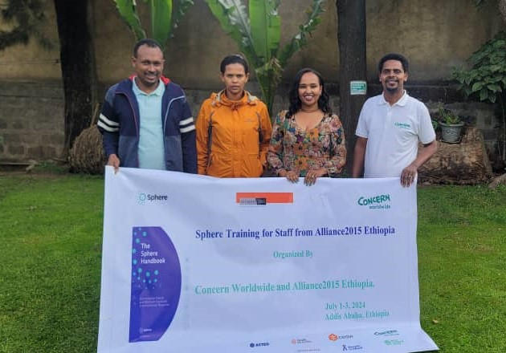

- Agenda by facilitator

