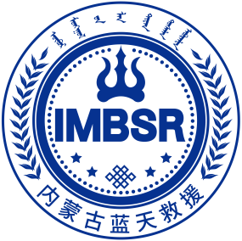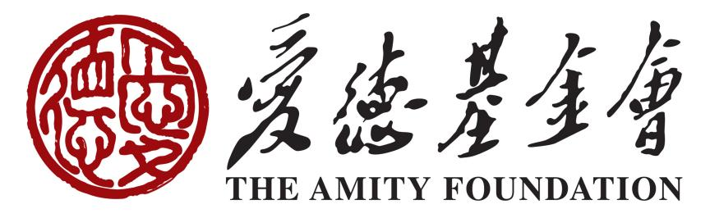

Sphere Training For Volunteer in Baotou
Baotou City, Inner Mongolia Autonomous Region, China
June 10 to 12 , 2023
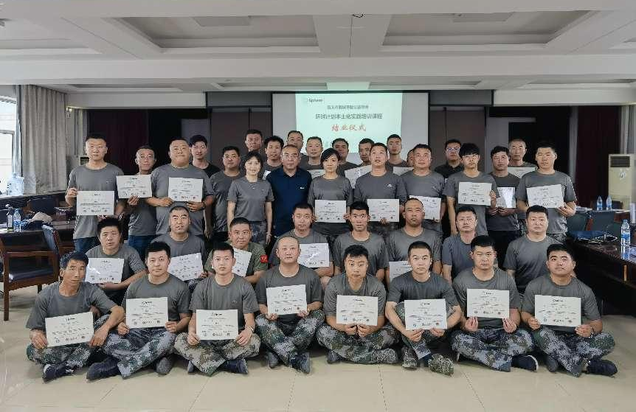
Background:
To improve the quality of humanitarian responses and to be accountable for the actions and, ensure that there are unified standards among all teams in future rescue activities and make it easier to promote communication and cooperation between brother rescue teams , Inner Mongolia Blue Sky Rescue Team and Baotou Lucheng Charity Association plans to conduct a three-day training course on the Sphere (2018) in Baotou from June 10-12, 2023.
This Training will focus on the four core technologies of humanitarian relief and the Sphere (2018), how to use the standards, and cross-cutting themes. Through training, different NGOs and rescue teams are able to master the methods, standards and principles of assistance to the affected people after disasters.
Through training, we promote the participation of actors in learning, and in addition to improving their own capabilities, they also establish a learning platform to exchange and share the knowledge they have learned with other partners, learn and grow together, and reflect on and summarize past disaster relief work together，and promote the use of harmonized standards for cooperation in future disaster assistance activities.
The event was organized by Inner Mongolia Blue Sky Rescue Association and funded by Amity Foundation.
HOST
The Workshop was hosted by the Amity Foundation & Inner Mongolia Blue Sky Rescue Association，and the local partner organization Baotou Lucheng Charity Association.
ABOUT INNER MONGOLIA BLUE SKY RESCUE ASSOCIATION
The Inner Mongolia Blue Sky Rescue Association was established in 2016 and was recognized as a charitable organization in 2017. At present, there are The Inner Mongolia Blue Sky Rescue Association was established in 2016 and was recognized as a charitable organization in 2017. At present, there are 14 Blue Sky rescue volunteer service teams and Inner Mongolia University of Science and Technology Blue Sky Rescue college student volunteer service team of , with a total of more than 3,000 volunteers engaged in various types of disaster and accident emergency rescue, psychological rescue, medical emergency rescue, community disaster prevention and reduction education, safety education and other public welfare activities.
In recent years, it has sent personnel to participate in the Jianli Yangtze River shipwreck in Hubei Province, the Nepal earthquake rescue, the psychological rescue of the Phuket Island shipwreck in Thailand and other large-scale rescue operations at home and abroad, and hundreds of humanitarian relief operations in the region. Inner Mongolia Blue Sky Rescue also actively carries out emergency skills safety education and community disaster prevention and reduction social services, and has set up three public electives in the university, "Emergency rescue", "Community emergency service ability" and "Sphere project", and provides emergency security work for various types of mass activities.
ABOUT THE AMITY FOUNDATION
The Amity Foundation, an independent Chinese social organization, founded in 1985 on the initiative of Chinese Christians led by Bishop K.H. Ting and joined by people from all walks of society, works to promote education, public health, social welfare, community development, environmental protection, disaster relief and other philanthropic undertakings in China and other parts of the world. Amity projects have benefited more than ten million people at home and abroad.
ABOUT BAOTOU LUCHENG CHARITY ASSOCIATION
Baotou Lucheng Charity Association founded in 2018, is a non-governmental organization engaged in emergency rescue, charity, safety education and other public welfare activities. There are more than 100 active volunteers who have participated in the Guyang flood assistance in Baotou and various rescue operations in the region.

PARTICIPATION:
Lead Facilitator: FU，Yu
Cofacilitator： Li ，Haifeng
Evaluator: Li ，Haifeng
Trainee：53 volunteers of the Baotou Lucheng Charity Association
Goals/learning objectives:
- Proficiency in Sphere 2018 Chinese.
- Apply the Sphere 2018 Chinese to design humanitarian relief projects.

AGENDA:
June 10
Time | content | Objectives
8:30–8:45 | The organizer gave a welcome speech, Li Haifeng
8:45–10:15 | STP 1： Welcome and Introduction  Stp 2： What is Sphere?  Li Haifeng | - Follow the basic norms for this event  - Exchange information with your  - Explain what Sphere is in terms of “Learn, Act, and Connect”  - Concisely explain Sphere’s core philosophy  - Navigate the Sphere Handbook structure and components  - Advocate for using all of the Sphere Handbook in guiding humanitarian action  - Use the Code of Conduct to guide humanitarian response.
10:15–10:30 | Coffee break
10:30-12:00 | STP 4： Humanitarian Charter  STP 5： Protection Principles  Fu Yu | - Explain how the 12 elements of the Humanitarian Charter affect humanitarian response programmes  - Give examples of how these four protection principles have been put into practice throughout the humanitarian programme cycle  - Explain the need for professional standards for conservation work
12:00-14:00 | Lunch and lunch break
14:00-15:50 | STP 6：CHS  Fu Yu | - Locate and apply the nine commitments of the Core Humanitarian Standard (CHS) to your own work  - Identify challenges to humanitarians in meeting the commitments of the CHS and propose ways to overcome them.
15:50–16:10 | Coffee break
16:10–18:00 | STP 7：WASH  Fu Yu | - Explain the primary objective and three essential concepts behind WASH programming  - Identify the main transmission pathways of infectious pathogens and barriers to break the chains of transmission  - Relate the quantitative technical aspects of Sphere to its foundational rights-based aspects  - Local standards in water supply (GB)  - Assign group tasks

June 11
Time | content | Objectives
8:00–8:15 | Review and review, assessment feedback
8:15–9:45 | STP 7：WASH  Fu Yu | - Eight teams report on WASH tasks  - all groups share and cross-comment
9:45–10:00 | Coffee break
10:00-12:00 | STP 15： Sphere and PSEA  Fu Yu | - Explain the terminology  - Explain how sexual harassment, exploitation and assault are interrelated and what different protection and response strategies are needed  - Review institutional protection policies
12:00-14:00 | Lunch and lunch break
14:00-15:50 | STP 8 Food Security and Nutrition  Fu Yu | - Links between food security nutrition and other response areas  - Understand minimum standards for food security and nutrition
15:50–16:10 | Coffee break
16:10–18:00 | STP9 Shelter and Settlement  Fu Yu | - Emergency and long-term programmes for housing assistance  - China's relevant standards on housing resettlement GB  - Assign team synthesis tasks

June 12
Time | content | Objectives
8:00–8:15 | Review and review, assessment feedback
8:15–10:15 | STP10: Healthcare  STP 12: Sphere and the Programme Cycle  STP 13: Evaluation analysis  STP 17: Sphere, Cash and Markets.  Fu Yu | - Outlines priorities and objectives for the medical action area  - Outlines minimum standards in the medical practice area  - The basic concepts of project cycle management  - Cash and market assessment and analysis
9:45–10:00 | Coffee break
10:00-12:00 | Each of the eight teams collaborates on integrated disaster assistance tasks
12:00-14:00 | Lunch and lunch break
14:00-16:00 | Each of the eight groups shared the design of the aid project, and the remaining groups asked questions
16:00–16:20 | Coffee break
16:00–17:30 | STP 19 Advocacy  STP 20 Evaluation and Wrap-Up  Li Haifeng | - A general review of the course, reflect and evaluate this workshop activity  - Share learning experience  - Develop an action plan
17:30-18:00 | Graduation ceremony
This training was mainly based on scenario learning, and the curriculum also cited China's national standards. Taking natural disasters in China as a case study, each team was arranged to discuss two post-disaster assistance tasks, asking them to provide assistance in WASH, food and nutrition security, and housing for 6,000 people affected by floods.
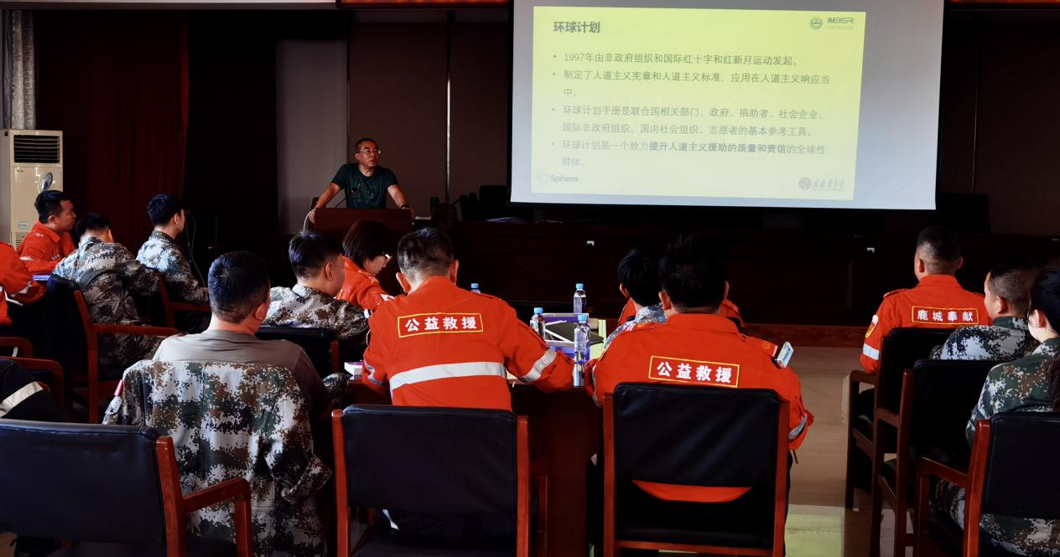
Fu Yu is introducing the Sphere Project to the trainees
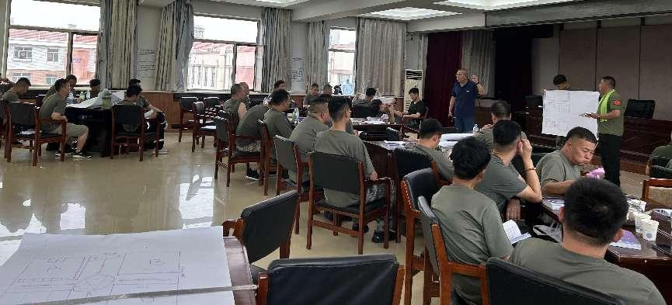Fu Yu is evaluating the trainees' tasks
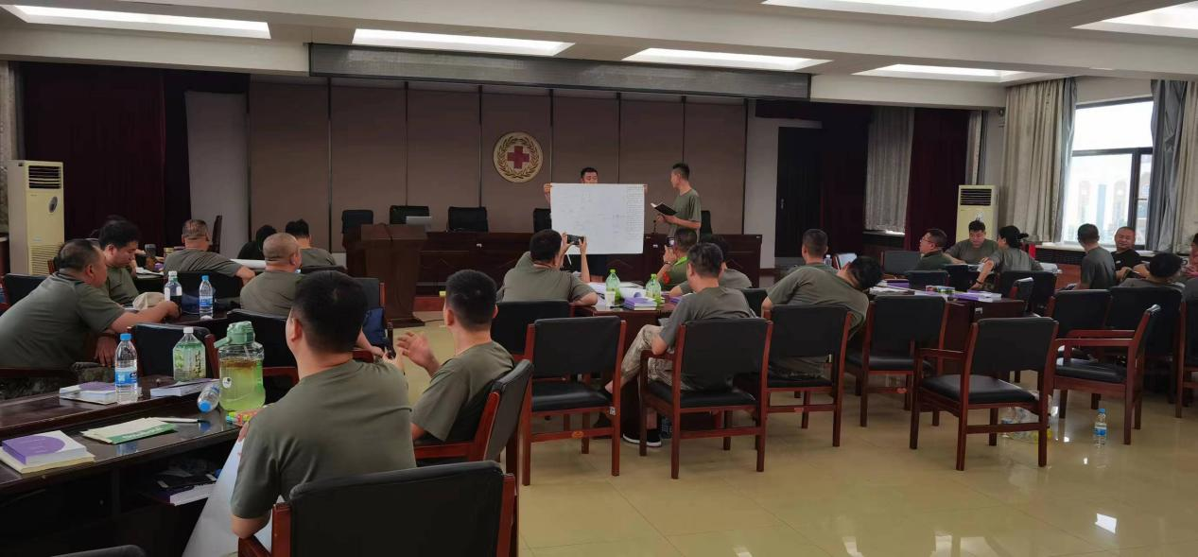The trainees are reporting on the group's mission
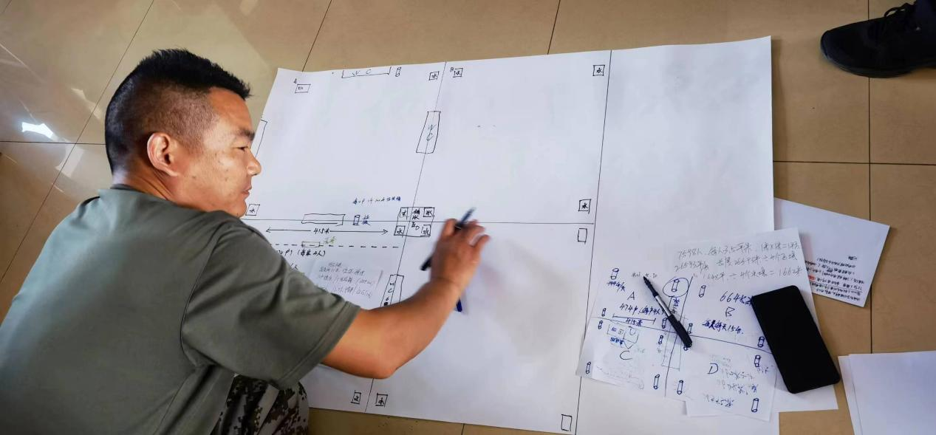Trainees are drawing a resettlement plan for people affected by disasters
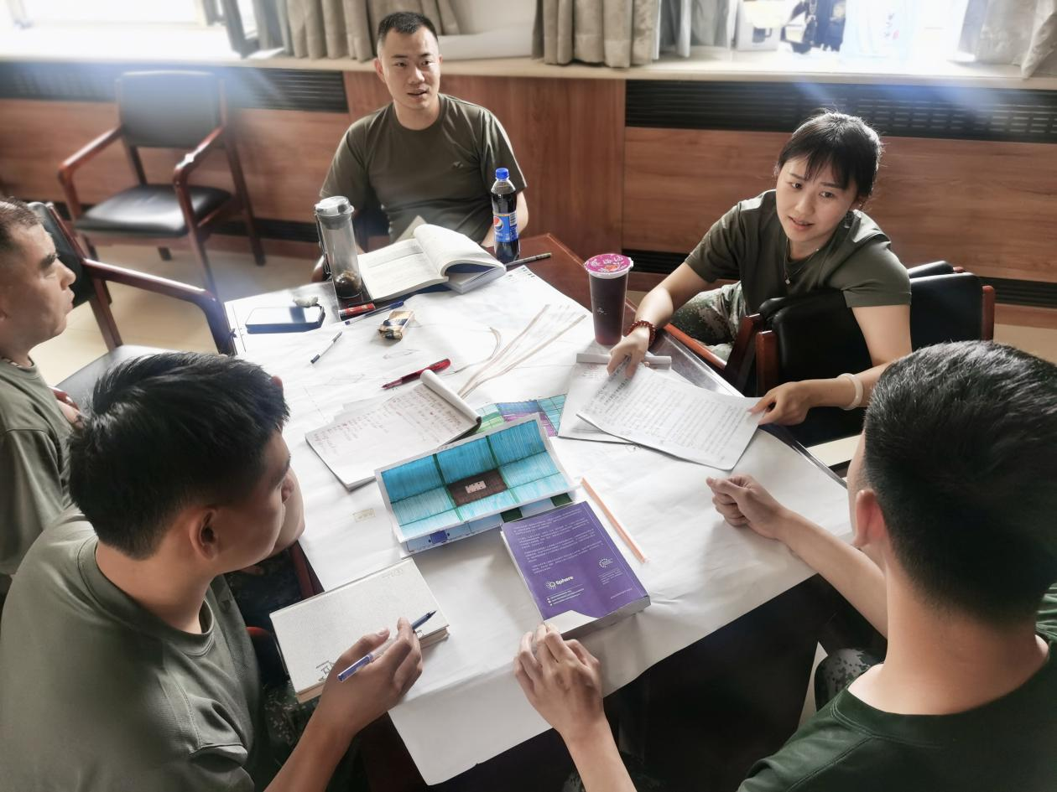
The group members are having a discussion
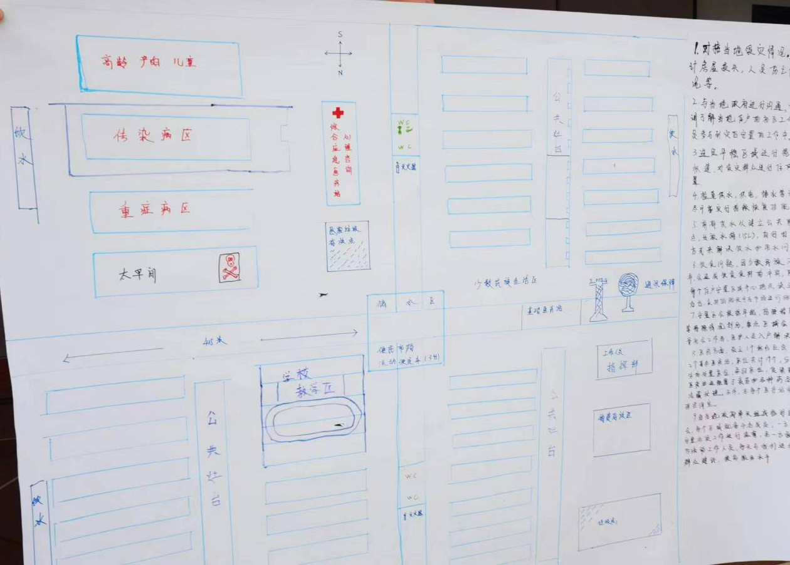
Map of the resettlement

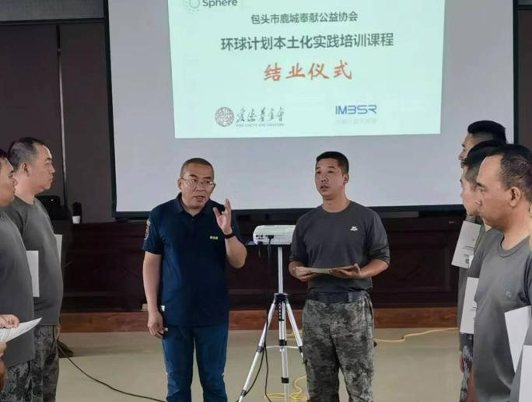
Fu Yu speaks at the graduation ceremony

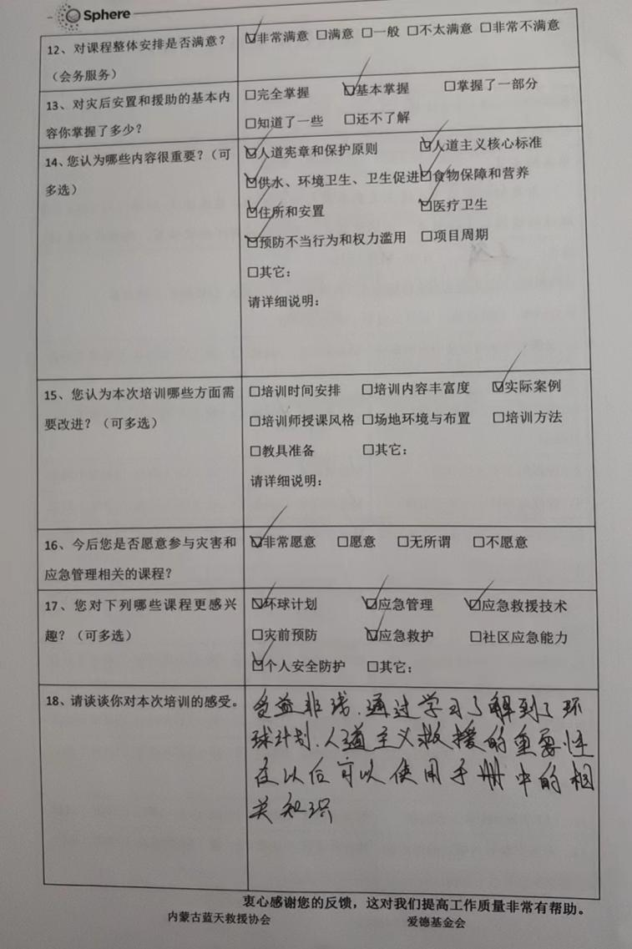
Course effect satisfaction feedback: Wang Zhi (trainee) said that he benefited a lot from learning the importance of the Sphere Project and humanitarian relief, and could use the relevant knowledge in the Sphere manual in the future.

